

CREATE TABLE BATCH_JOB_EXECUTION_CONTEXT (  
 JOB_EXECUTION_ID NUMBER(19,0) NOT NULL PRIMARY KEY,  
 SHORT_CONTEXT VARCHAR2(2500 char) NOT NULL,  
 SERIALIZED_CONTEXT CLOB ,  
 constraint JOB_EXEC_CTX_FK foreign key (JOB_EXECUTION_ID)  
 references BATCH_JOB_EXECUTION(JOB_EXECUTION_ID)  
) ;  
**CREATE** **TABLE** customers

( id number(10) NOT NULL,

**name** varchar2(50) NOT NULL,

  city varchar2(50),

**CONSTRAINT** customers_pk **PRIMARY** **KEY** (id)

);

CREATE SEQUENCE BATCH_STEP_EXECUTION_SEQ START WITH 0 MINVALUE 0 MAXVALUE 9223372036854775807 NOCYCLE;  
CREATE SEQUENCE BATCH_JOB_EXECUTION_SEQ START WITH 0 MINVALUE 0 MAXVALUE 9223372036854775807 NOCYCLE;  
CREATE SEQUENCE BATCH_JOB_SEQ START WITH 0 MINVALUE 0 MAXVALUE 9223372036854775807 NOCYCLE;

Platform specific queries available in below jar

Go to the jar and open that package an u will see the script used by spring to create tables

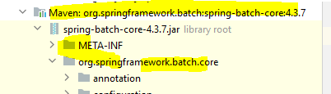 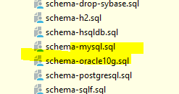

  @PostConstruct

    public void init(){

     /*   jdbcTemplate.execute("CREATE TABLE customers    \n" +

                "( id number(10) NOT NULL AUTO_INCREMENT,\n" +

                "  name varchar2(50) NOT NULL,    \n" +

                "  email varchar2(50), \n" +

                "  created_date DATE\n" +

                "\n" +

                ");    ");*/

        jdbcTemplate.execute("insert into customers ( name,email,created_date) values ('fresco', 'fresco@tcs.com','2020-06-11')");

        jdbcTemplate.execute("insert into customers ( name,email,created_date) values ('play', 'play@tcs.com','2020-06-11')");

    }